How to Use Classroom
In October 2026, our Teacher/Student functionality received an overhaul and name change. It is now called Classroom and can be accessed from the main navigation menu.
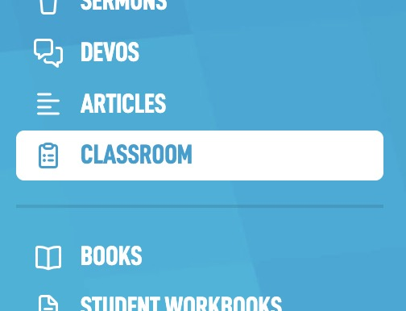
In this help guide we will go over how to set up your class.

Setting up Your Class
The navigation for Classroom is all found at the top middle of the screen. Navigate to the Classes section.
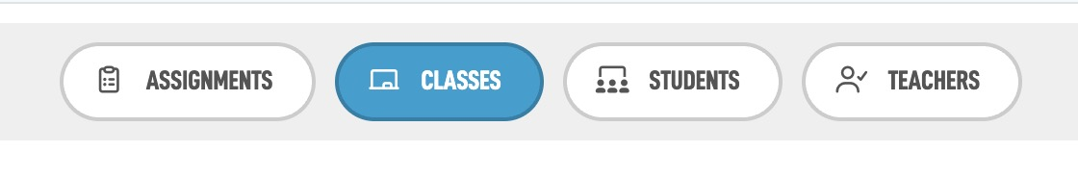
On that screen you will see a Create Class box. Give your class a name, and if you would like a description that can help users know what it will be about or where it is located.
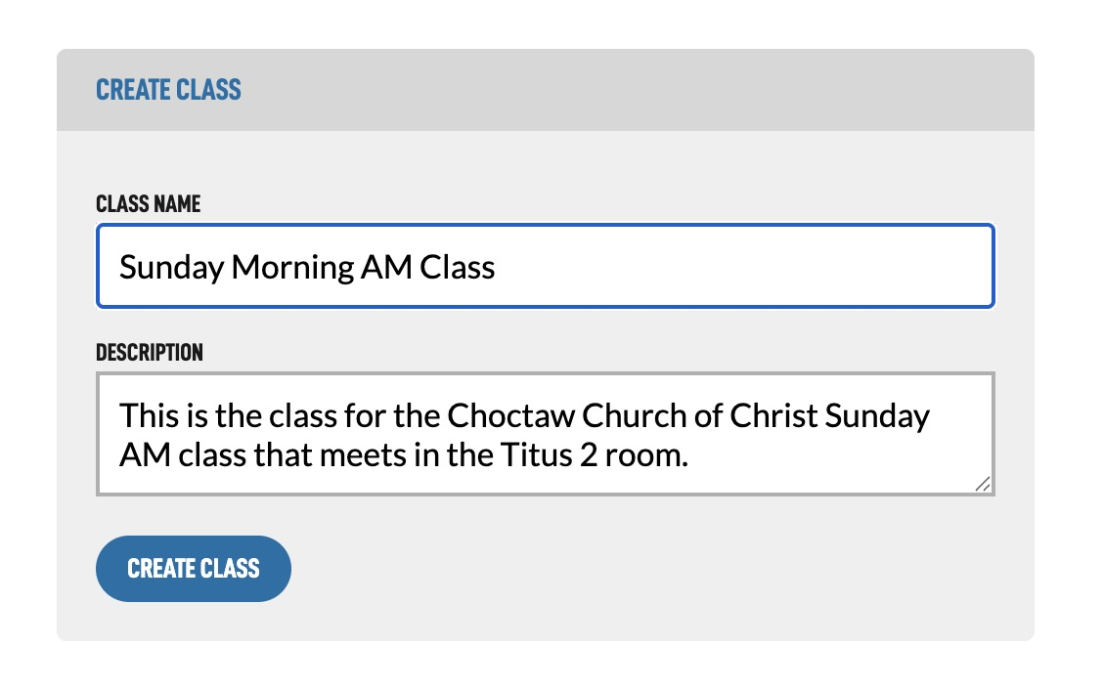
On the next screen, you will see your assignments area, followed by the potential students you have and then the ability to change the class name and description if you need to later on.
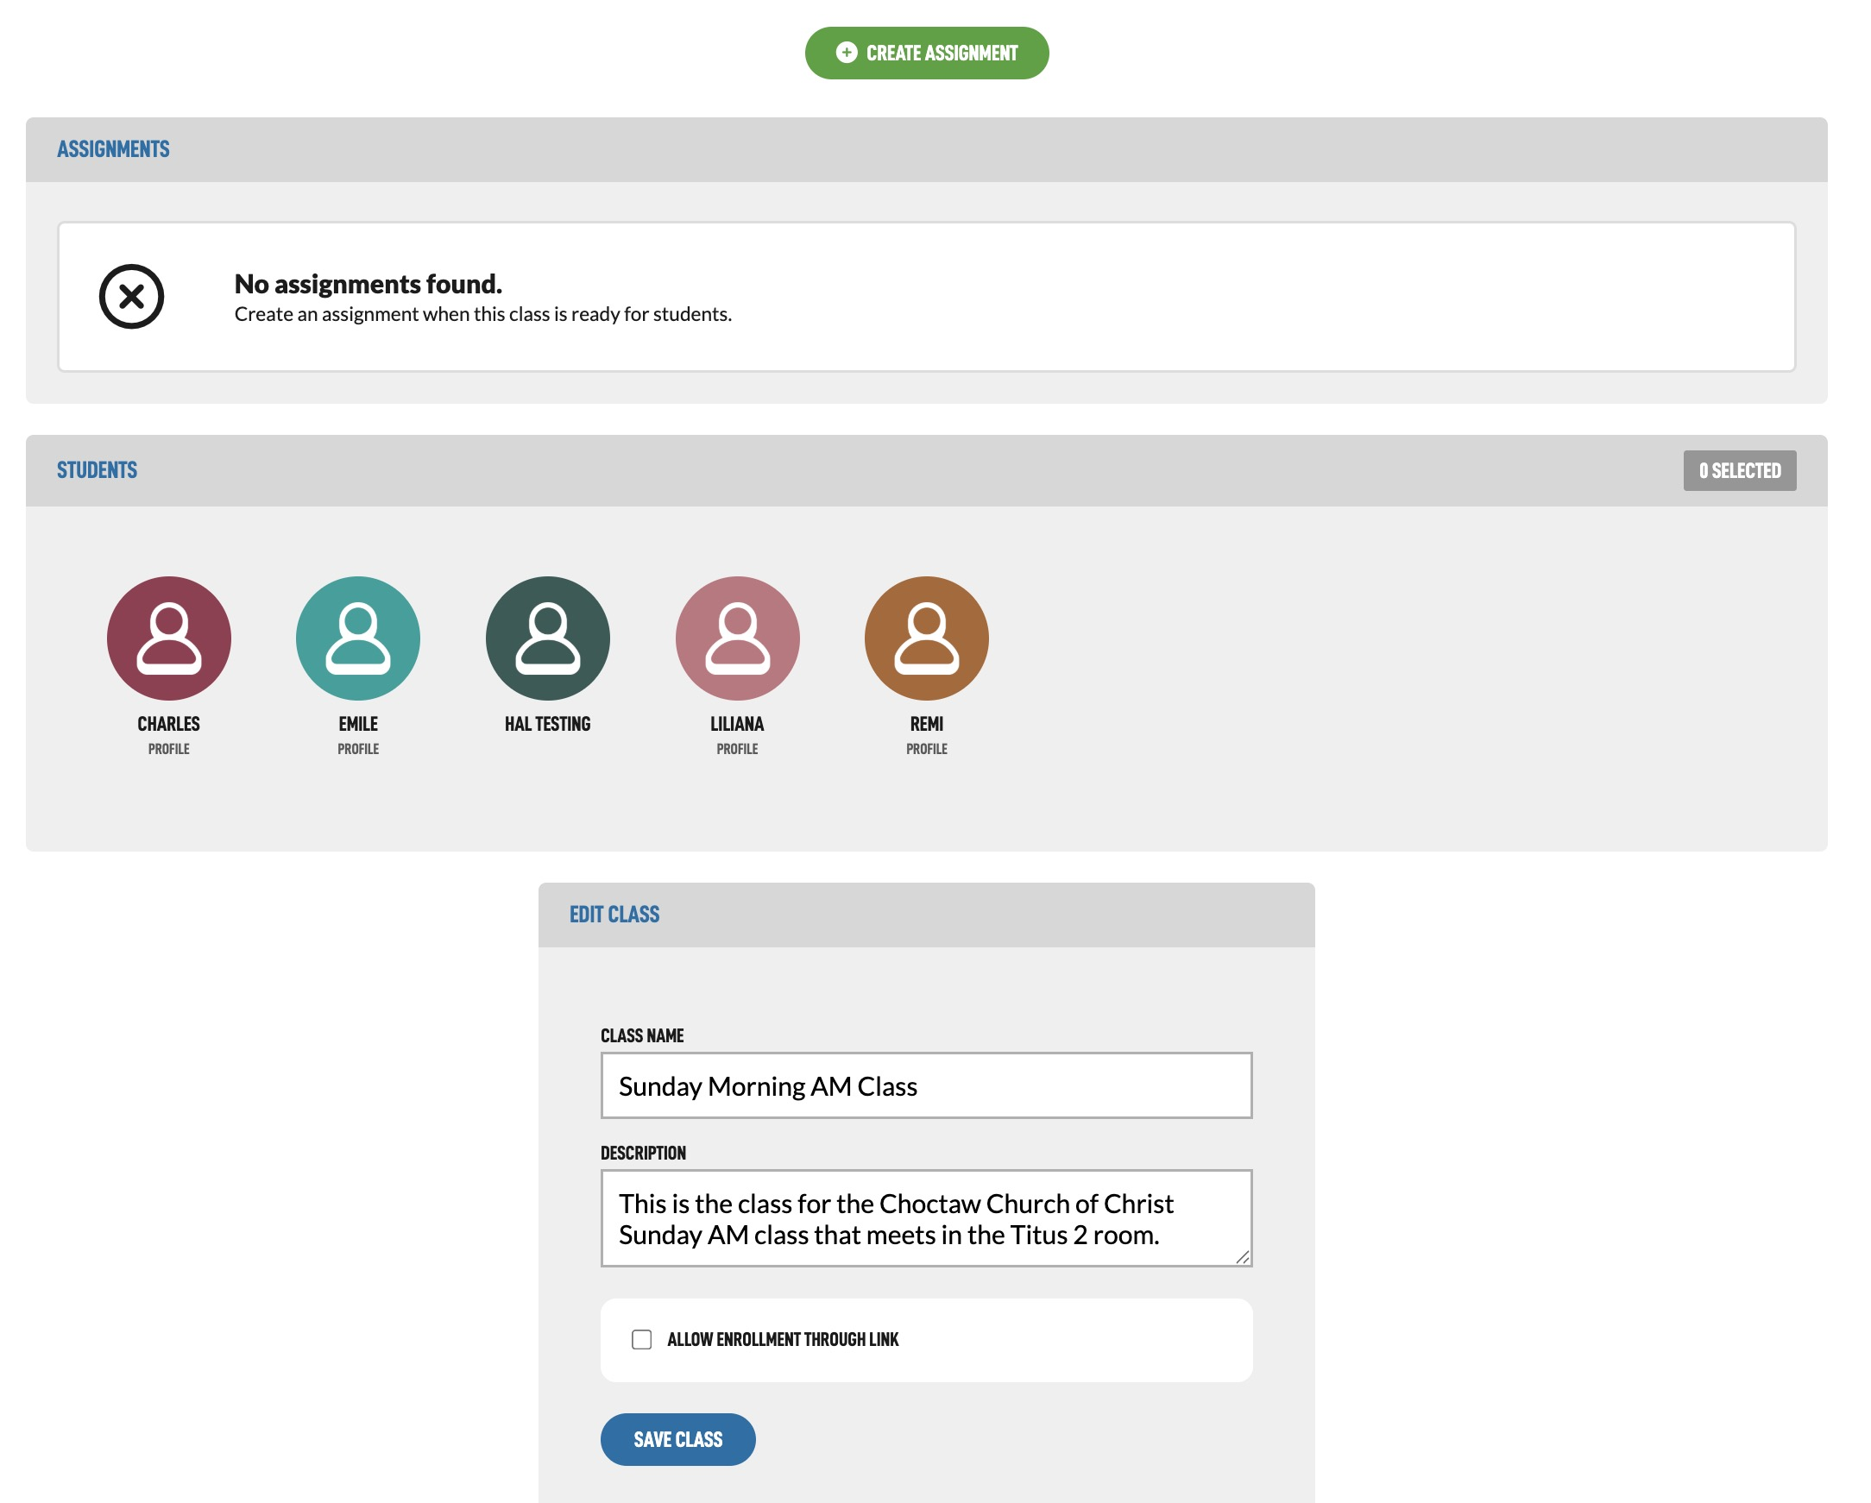

Adding Students
There are two ways to get users into your classroom.

Adding students using a link
The first is to select the Allow Enrollment Through Link option in the Edit Class form at the bottom of the class edit screen.
After selecting that box and tapping Save Class, you will then be shown a link that you can send to your students. After they sign up or log in to their BibleTalk.tv account, the link will automatically add them to your class.
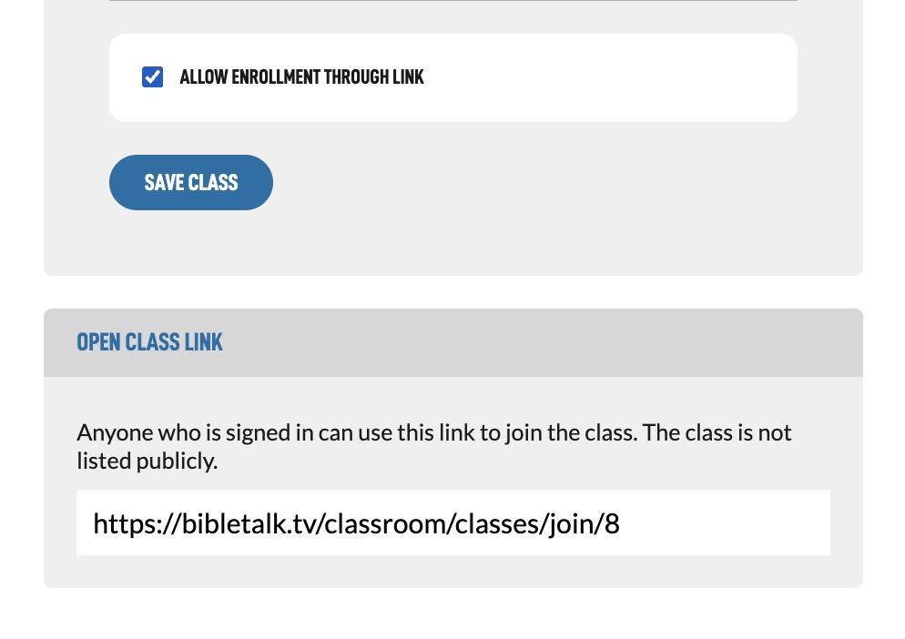
Once you have all your students in the class it is a good idea to go back and turn this off.

Adding students with your username
The second way to get students in your class is using a teacher username. Navigate to Students to set this up.
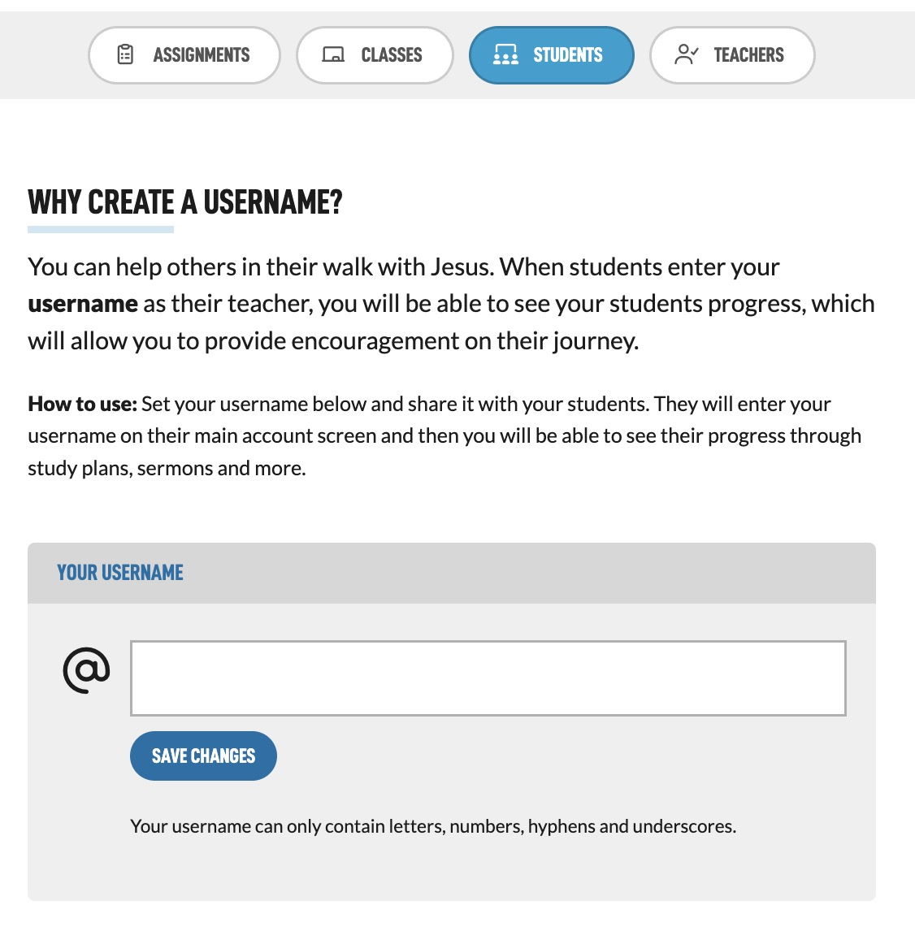
Add your username in the field and hit Save Changes. After the page reloads, you will see a link to your username. This is what you will share with your students to get them connected to your classes.
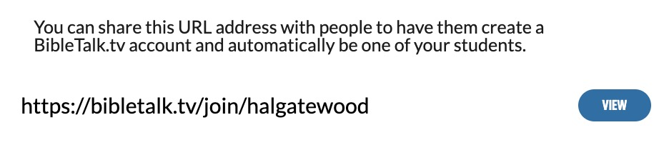
After students have logged in or registered and gone through your link, the Teacher/Student connection should be complete and you can now add them to your class.
Navigate back to the Classes section and select on the class you wish to edit.
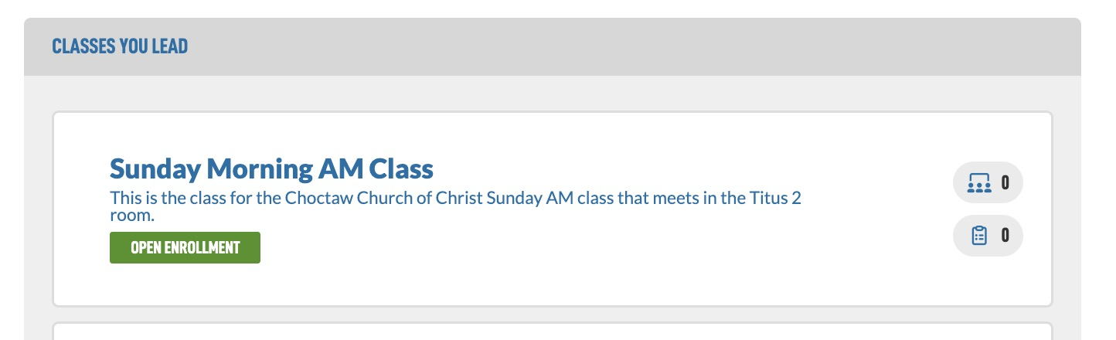
Then navigate down to the Students area and select the students you want in this class. A green circle will surround the image when selected.
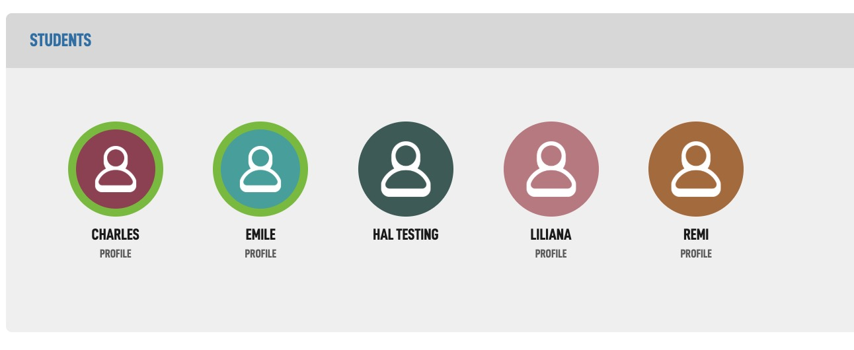

Creating Assignments
Now that you have some students, let's create assignments for them to complete.
At the top of the screen select the Create Assignment button.
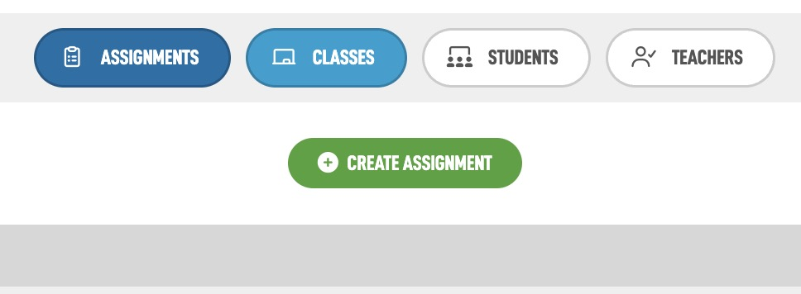
Your class should already be selected in the dropdown at the top. You can then choose from three assignment types:
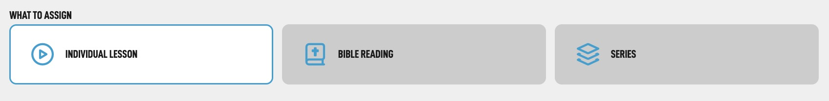

1. Individual Lesson
You can select a single piece of BibleTalk.tv material for them to complete. The student will need to use the Mark as Completed button found on every lesson and if there is a quiz for that lesson, complete it as well. Let's go over the form options for this type of assignment.
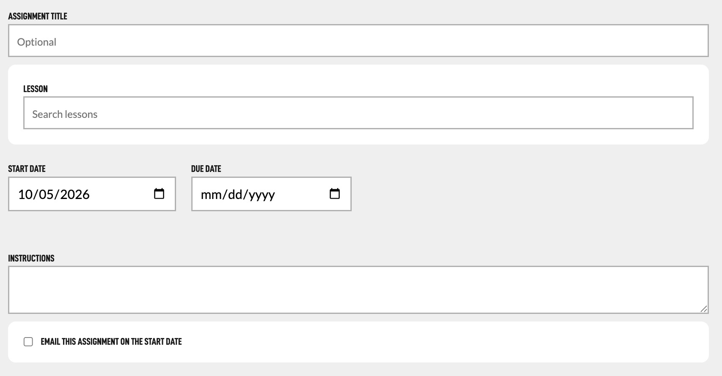
- Assignment Title – You can give the assignment a custom title or allow the system to title the assignment based on the lesson selected by leaving this blank.
- Lesson – Tapping in to the select box will open a pop-up list of the lessons available on the site. You can also search for the lesson by typing in the field, which will narrow down the options.
- Start Date – Choose the date this assignment will start. Choosing a date in the future will keep it hidden from your students until this date.
- Due Date – Create some urgency by setting a due date. This is optional.
- Instructions – You can add some custom instructions or extra things for them to do in this block.
- Email this assignment on the start date – This will send assignment notification emails on the start date.

2. Bible Reading
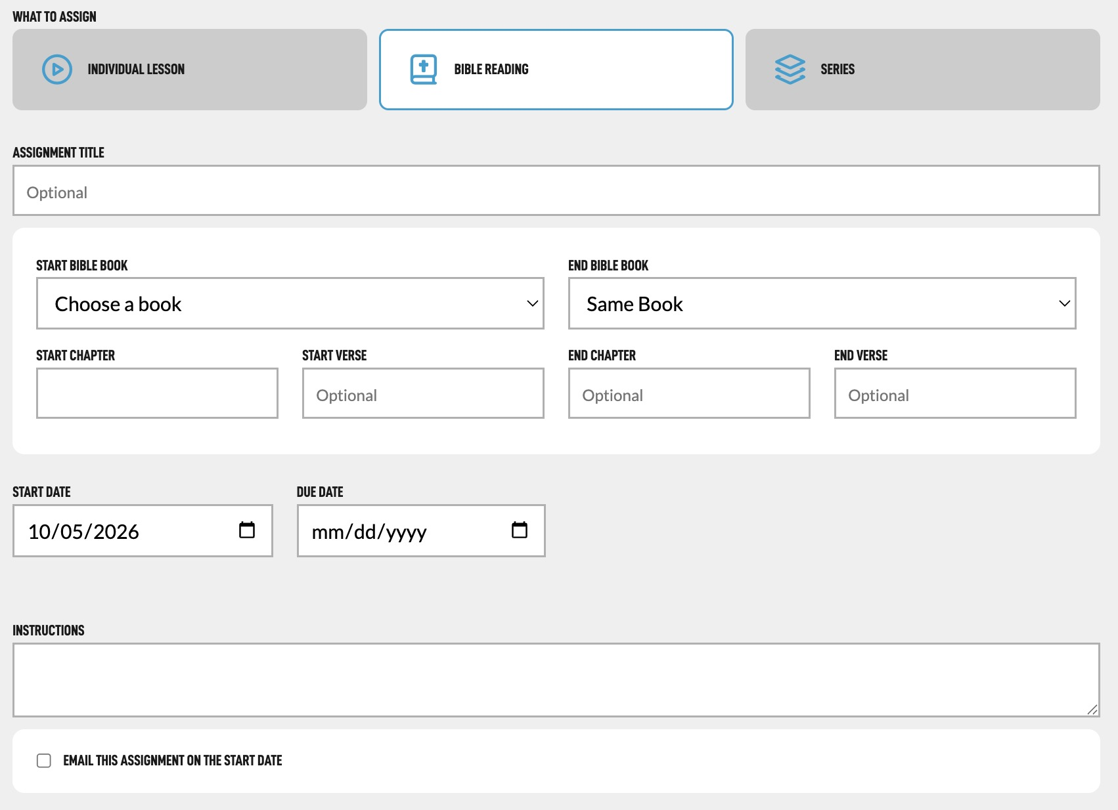
- Assignment Title – You can give the assignment a custom title or allow the system to title the assignment based on the Bible Reading selected by leaving this blank.
- What to Read – Use the Start Bible Book, End Bible Book and Chapter Verse options to create the exact Scriptures your student will need to read. Note in the form that some of the fields are optional allowing you to specify specific chapters or chapters and verses.
- Start Date – Choose the date this assignment will start. Choosing a date in the future will keep it hidden from your students until this date.
- Due Date – Create some urgency by setting a due date. This is optional.
- Instructions – You can add some custom instructions or extra things for them to do in this block.
- Email this assignment on the start date – This will send assignment notification emails on the start date.

3. Series
You can assign a whole BibleTalk.tv series in one form instead of going lesson by lesson using this option. The form has two steps to get working.
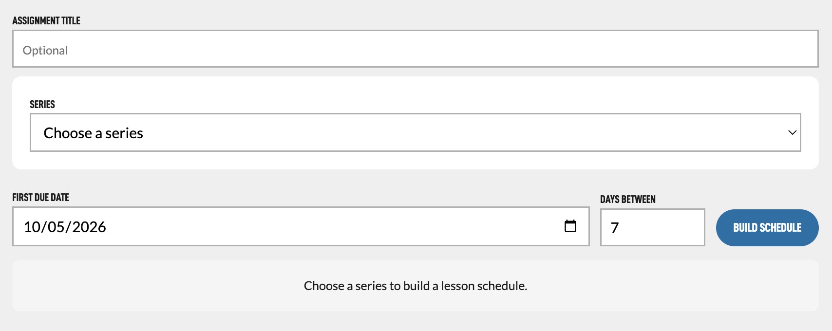
First select from the Series dropdown the Series you would like to assign. I've chosen a series with 4 lessons called Achieving Greatness. After selecting it, the lessons will load below.
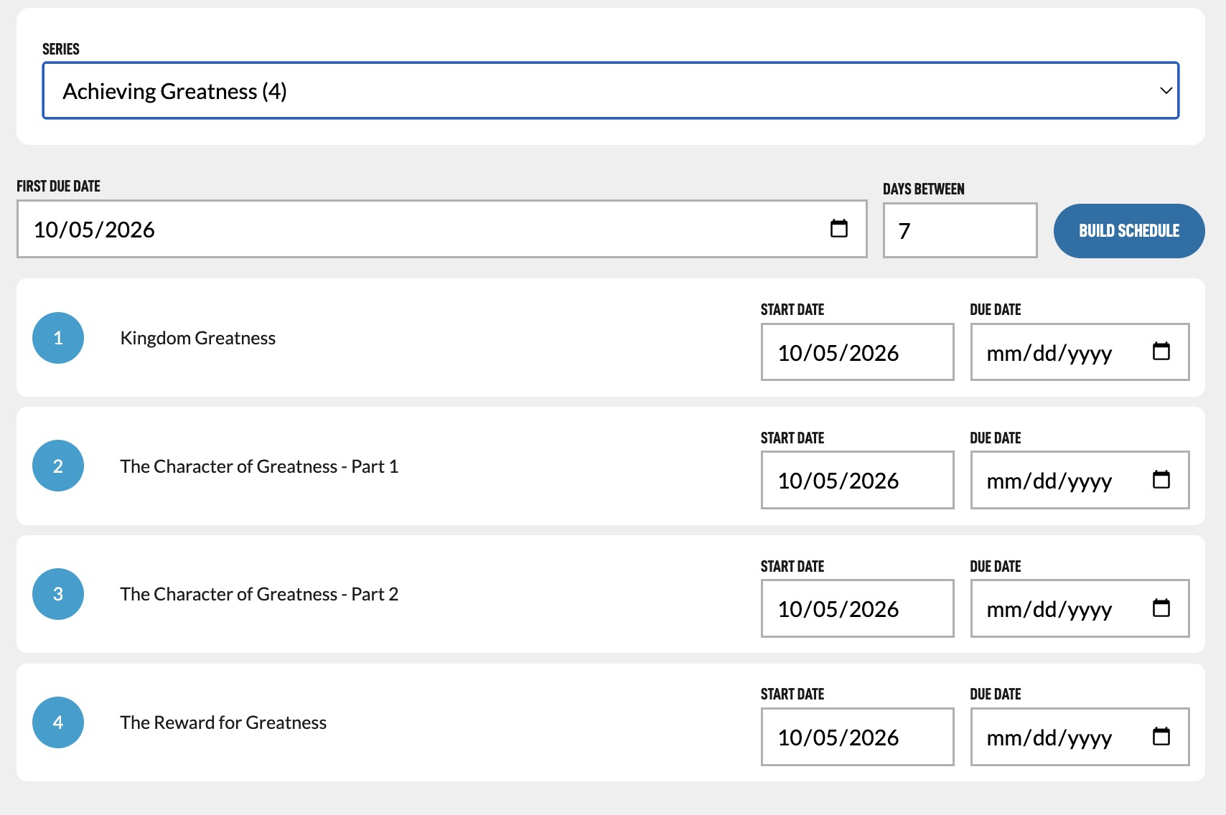
You can set a start date and due date for each lesson individually. To build a schedule automatically, choose a First Due Date, specify the number of days between due dates, and tap Build Schedule. You can rebuild the schedule or adjust individual dates as needed.
You can hit this multiple times until you get it right and even change just certain ones after that.
Then you can continue down and hit Create Assignment when you are ready and it will queue all the lessons.

Editing Assignments
Now that you have added some assignments, you can see them in your Classes or Assignments areas.
In the example below I added a Bible Reading in as well.
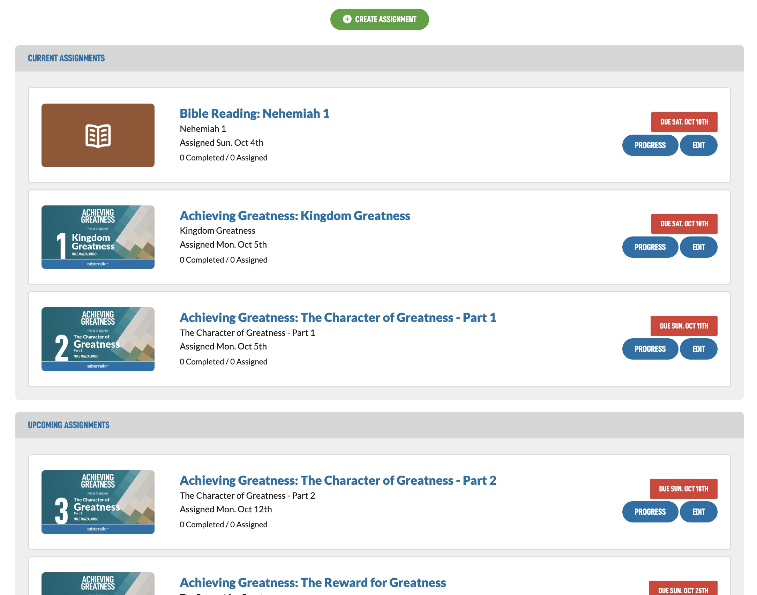
To edit the assignments tap the Edit button and you will be presented with a screen similar to the one you used to create the assignment.
Note that Series assignments are converted into individual lesson assignments so the Series option is not visible on this form anymore.
Reset Completed Status for Students – To reset an assignment's completion status for all students, select this checkbox and tap Update Assignment. This will mark the assignment as not completed for everyone.

Monitoring Student Progress
On the class page you can tap the Progress button to see what your students have been up to.
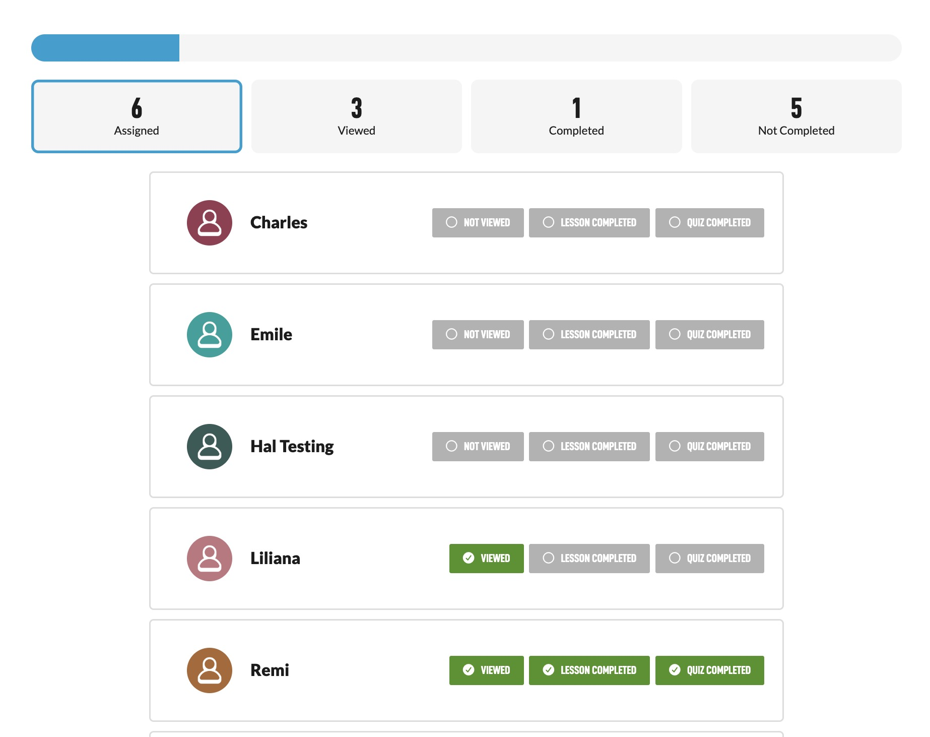
The grey bar in the middle is a progress bar for the whole class.
Then you can tap on each of the boxes to filter which students are at what stage of the assignment.
You can see if they have even viewed the assignment as one of the options.

