Making the Right Decision
Proverbs 16:33
I remember in 1993 when I quit my job at Oklahoma Christian University (OC) as Dean of Students to come preach at Choctaw Church of Christ, one of my co-workers at the college said to me, "I sure hope you're making the right decision."
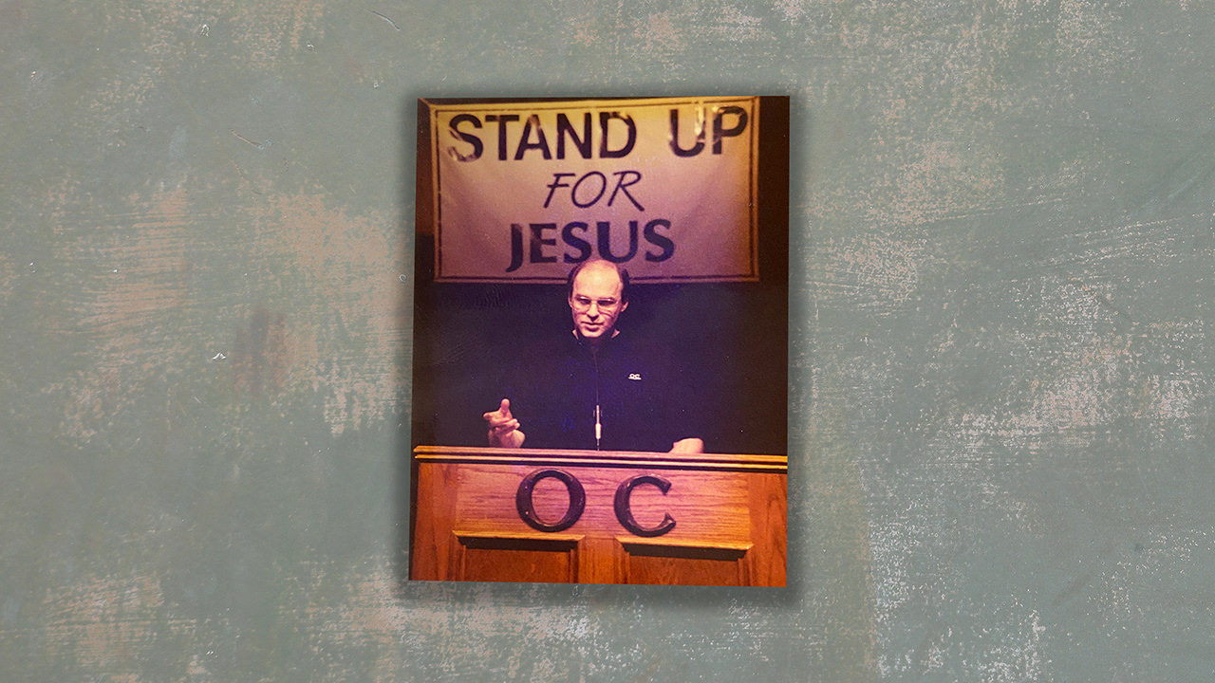
One of the greatest gifts that God has given to man is the ability to choose. It is one of the major differences that separates us from lower forms of life. It is the "free will" characteristic in our natures that enables us to be conscious of God's presence. Free will is that quality we have that enables us to be conscious of ourselves and consequently conscious of God and like God.
However, there are problems attached to this gift – We know we can choose but many times we don't know what to choose. (Most common problem in counseling especially for variety of choices that are not moral in nature).
I think the reason why we have so many difficulties in making decisions is that we don't have any method that we can use to help us make our decisions – standard criteria used in all decision making.
Today I would like to give you some key questions you need to ask yourselves when, as Christians, you are making important decisions. Because, in the end, the key to making good decisions is to find the right questions to ask, and then answer them honestly.

Questions

1. Is it Right or Wrong?
An honest answer to this question eliminates a lot of problems. We Should always ask this question first.
For example, Adultery and fornication confuse a lot of people because they decide to engage in it on the grounds that they are lonely, couldn't help themselves, in love, in need but never stop to ask the question, "Is this right or wrong, before they plunge into a sinful relationship, or sinful conduct.
When facing a choice, any choice, ask 3 sources if what you are about to do is right or wrong.
- Ask the Word – John 12:48b – "..the word I spoke is what will judge him at the last day."
- Ask your conscience – Romans 14:14 – "But to him who thinks anything to be unclean, to him it is unclean." If either says it is wrong, don't!
- Society – For added measure (does it contravene popular values...) In other words, do even people in the world frown on what you are doing?
Don't violate the Word, your conscience or even the world.

2. How Will This Affect my Faith?
Many times, the choice involves situations which are neither right nor wrong – they will simply change my circumstances or relationships. In these situations, I need to examine these circumstances in light of my personal growth as a Christian. A series of questions need to be asked to see how my decision will affect my faith.

a. Will my choice lead me into greater occasions of temptation to sin?
For example a man who has problems with worldliness decides to pursue a career where financial gain is the ultimate goal.
¹⁰ For the love of money is a root of all sorts of evil, and some by longing for it have wandered away from the faith and pierced themselves with many griefs. ¹¹ But flee from these things, you man of God, and pursue righteousness, godliness, faith, love, perseverance and gentleness.
- I Timothy 6:10-11
It is impossible to avoid temptation and sin since it is present everywhere, however we should avoid situations where it is easily and largely present or the sin(s) that you are particularly vulnerable to are present (Alcoholics shouldn't be bartenders).
We do not help our personal development by placing ourselves in a situation where we constantly need to battle with temptation. Temptation will come, there is no need to purposefully put ourselves in its way.
For what will it profit a man if he gains the whole world and forfeits his soul? Or what will a man give in exchange for his soul?
- Matthew 16:26

b. Will my choice affect my service to Christ?
For example a person chooses a situation where he/she will not be able to attend all the services, read and share the gospel, serve the church, exercise his/her gifts, develop relationships with other Christians.
God's first priority is the Church and if you wish to do His will, you mut keep His church as a high priority! More money, prestige, comfort and success in the world does not advance the kingdom of God nor does it contribute to the saving of your soul.
Christ, the King of kings, abandoned His throne and died as a servant to save our souls – why is it so surprising to us that sometimes worldly advantage has to be sacrificed in order to preserve our souls and save others! Why is it that we think that we don't have to make sacrifices?

3. How Will My Decision Affect the Faith of Others?
³ Do nothing from selfishness or empty conceit, but with humility of mind regard one another as more important than yourselves; ⁴ do not merely look out for your own personal interests, but also for the interests of others.
- Philippians 2:3-4
What we do, in many ways sets the standard for the behavior and thinking of others. Those without Christ need not concern themselves with what others think but we do because we are responsible for others in the eyes of God.
When making a choice about your own life and behavior (whether you are going to start doing something or stop doing something) ask yourself the following questions to see how your choice will affect the faith of others. (When people look at me, what do they see?)
Will my choice cause others to rejoice or be saddened, discouraged. For example, if I leave preaching to go into writing fiction novels or acting? Will my choice cause others to see Christ more clearly in me or merely create doubt or suspicion about my sincerity, spirituality, maturity, morality.
Can I wholeheartedly encourage others to follow my lead? Will this choice bring me closer to the brethren or farther away?
We cannot please God and do His will if what we choose negatively affects the faith of others – Jesus' worse condemnation was for those who destroy the faith of others!
but whoever causes one of these little ones who believe in Me to stumble, it would be better for him to have a heavy millstone hung around his neck, and to be drowned in the depth of the sea.
- Matthew 18:6

The Other Questions
Now, these three questions are not the only questions to ask but they should be the first ones asked. Many times we decide if the money is right, the weather is pleasant, if there are good schools or whether or not the choice we face will make my family or myself happy.
All legitimate concerns that need to be answered but the questions I presented to you this morning need to be answered first if these others are to have proper meaning and perspective. Also, be assured that "if you seek the kingdom first" in your decision making, God will bless your plans and watch over you.

Why The Struggle?
Sometimes we ask the right questions and still struggle with the decisions we have to make, "why does this happen?" There can be several reasons for an ongoing struggle in decision making:
- We struggle because we are trying to keep our eyes focused only on the good part of a bad choice. we are not being honest with ourselves. For example, we're in a bad relationship and trying to decide if we should marry or not, which is the wrong question to ask.
- We struggle because we rationalize or make excuses for an imprudent or selfish choice. For example an expensive purchase (like buying a new car to "save on gas").
- We struggle because we are fighting temptation but we are not conscious of it. For instance when we watch movies with bad language or explicit sex scenes or drastically violent. How much mud do we want to wade through to get to a "pearl."
We struggle because we want to serve God and Mammon at the same time and this is very tiring to the spirit. When we make the right choice, we have usually answered the right questions honestly and there is peace. This is the mark of a good decision.

Summary
What guide do we use when making major decisions? Do we have a way to decide directed by the Holy Spirit, or do we:
- Decide, like non-believers do, based on self-interest and desire. Where choice is based solely on feeling and accomplished through willpower and human skill.
- Decide like the Jews did in Jesus' time, looking for signs in the circumstances. More superstition than faith.
- Or do we ask ourselves the following key questions: Is it right or wrong according to the Word, conscience and others? How will this affect my faith? How will it affect the faith of others?
The right decision will be obvious because:
- it will be worthy of praise and honor because it is good.
- it will provide greater opportunities for Christian growth and service.
- it will serve and edify others.
And that will bring us peace with what we have decided.

Exhortation
We all have to make important and difficult choices in life. Today we have discussed a sound strategy to use in making the right decision. Today I also offer to all the opportunity to make two decisions that will affect every other decision you will ever make.
- Decide today that you will become a Christian if you are not already or return to Christ if you have been unfaithful.
- Decide that you will ask yourselves these questions and answer them honestly when making decisions in the future.
Finally, when all the praying and thinking and questioning is over, and you have finally decided:
If the choice proves to be a good one, don't forget to give the credit and thanks to God so He will bless you in future decisions. If you blow it – don't get mad at yourself or God or the church. Just start over again knowing that God can work things out to His glory even with our bad decisions.
By the way, that decision I made to come here from OC 33 years ago, I've never regretted for a moment. It was the best decision of my life and God has blessed me richly because of it.
And so, if you've made the decision to come to Christ or to come back to Christ, a decision you'll never regret, I encourage you to express that choice by coming forward now as we stand and sing the song of invitation.

